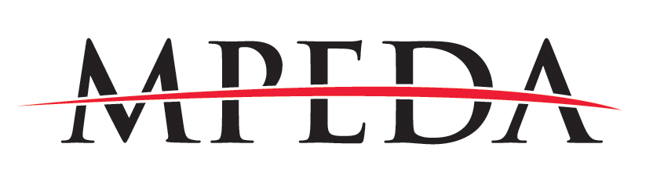
P.O. Box 437• 154 East Lake Drive • Medicine Park, OK 73557-0437
(580) 529-2825 • FAX (580) 529-3110

Sponsorship Opportunity: Medicine Park Events 2022

The Medicine Park Economic Development Authority is preparing for its 2022 events season. We are seeking sponsorships from the private and corporate realm in support of our events. Please join us in support of these free events for the public that offer entertainment as well as cultural enlightenment.

Sponsorship levels for each event are:
.
Bronze level: $100-$249 sponsors will have your name on the T-shirt and receive mentions from the stage.

Silver level: $250-$499 sponsors will have your name on the T-shirt and print materials. receive mentions from the stage and in press coverage. You will also receive one event T-shirt.

Gold level: $500-$999 sponsors will have your logo on the T shirt and all print materials, receive mentions from the stage and in all press coverage. Your banner, provided by you, will be placed in front of or to one side of the event stages with high visibility. Gold sponsors will receive two event T-shirts.

Platinum level: $1000+ sponsors will have your logo featured on all print materials and T-shirt, receive mentions from the stage and in all press coverage. Your banner, provided by you, will be placed in front of or to one side of the main stage with high visibility. Platinum sponsors will receive four event T-shirts.

We would like to present this proposal format to allow sponsors a look at the entire season to budget for the year or to choose individual events and levels of support. This format can provide for a simpler, single process for all involved, resulting in less paperwork and accounting activity rather than a proposal for each event, cutting a check for each event and so on. Event sponsorship can still be on an individual basis per event if so desired by you.

This year's sanctioned MPEDA events are:

Polar Plunge Week (3rd year) Jan. 29 through Feb. 5. A week of chilling out in the Park, beginning with the Polar Prom and continuing with a week of fascinating and fun events, morning, afternoon and evening; and ending with the traditional warm-up at Park Tavern, parade and plunge in Bath Lake. See the calendar for more information.
Parkstomp (13th year) March 18-20.Two days of the best jazzed-up hillbilly bluegrass music presented live at the new stage in Hitchin’ Post Park. Also a VW car show --“V-Dubs in the Park.”

Fools’ Dozen (5th year) April 1, 2 and 3. Mountain bike rides, races, music and Mountain Bike Race events featuring the Trails of Medicine Park.
.
The Roots Ball (5th year) May 28, 29 and 30 This event features live Americana/Roots music over Memorial Day weekend.

Rock N the Park (9th year) July 2, 3 and 4 The Medicine Park Birthday celebration combined with a festival celebrating authentic American Rock music, fireworks and Jeeplahoma returns featuring a Jeep show and shine.

The Blues Ball (16th year) Sept. 2, 3 and 4 Our premier event that features live. authentic Blues music throughout town over the Labor Day weekend.

The Medicine Park Flute Festival and Artwalk (13th year) Oct. 8 and 9 Native American Flute music, and a juried art show featuring regional and local artists.

All sponsorships will receive a letter of appreciation and a receipt acknowledging your support.
Sponsorship checks can be made out to MPEDA and mailed to:

Medicine Park Economic Development Authority (MPEDA)/ Event sponsorship
PO BOX 437
Medicine Park, OK 73557

Thank you for your support,

Dwight Cope
Events Coordinator
Medicine Park, OK
Cell # 580-529-9528

